**Practical No -5**

**Write a Stored Procedure namely proc_Grade for the categorization of student. If marks scored by students in examination is <=1500 and marks>=990 then student will be placed in distinction category if marks scored are between 989 and900 category is first class, if marks 899 and 825 category is Higher Second Class Write a PL/SQL block for using procedure created with above requirement. Stud_Marks(name, total_marks) Result(Roll,Name, Class)**

**Table-**

create table marks(

rollno number(10),

name varchar2(20),

sub1 number,

sub2 number,

sub3 number,

sub4 number,

sub5 number

);

----------------------------

insert into marks values(1,'ganesh',250,110,113,141,212);

insert into marks values(2,'santosh',201,122,105,210,110);

insert into marks values(3,'ramesh',110,90,110,210,140);

insert into marks values(4,'kamal',202,70,80,150,140);

insert into marks values(5,'sadan',110,150,140,144,120);

---------------------------

select * from marks;

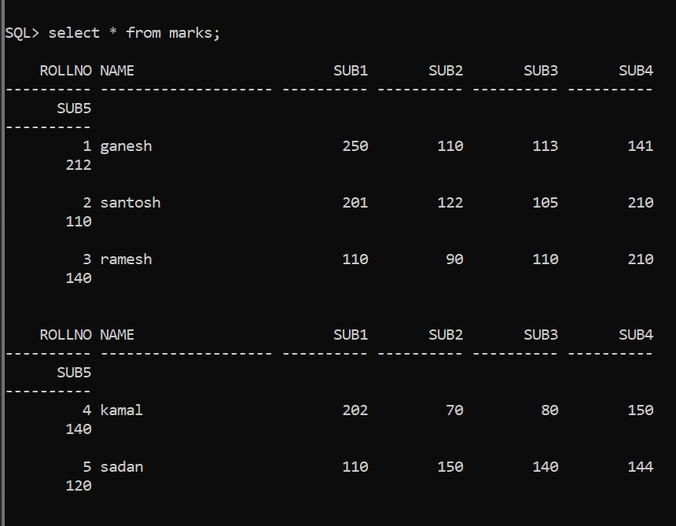

---------------------------

**table**-

create table stud_marks(

rollno number(10),

name varchar2(20),

total_marks number(10)

);

---------------------------

**table**-

create table Result(

rollno number(10),

name varchar2(20),

class varchar2(30)

);

---------------------------

**Procedure**:-

create procedure PROC_GRADE is

sum number(20);

i number(20);

n number(20);

rollnol number(10);

namel varchar2(30);

totall number(10);

classl varchar2(30);

s1 number;

s2 number;

s3 number;

s4 number;

s5 number;

begin

select count(*) into n from marks;

i:=0;

loop

i:=i+1;

select rollno into rollnol from marks where rollno=i;

select name into namel from marks where rollno=i;

select sub1 into s1 from marks where rollno=i;

select sub2 into s2 from marks where rollno=i;

select sub3 into s3 from marks where rollno=i;

select sub4 into s4 from marks where rollno=i;

select sub5 into s5 from marks where rollno=i;

totall:=s1+s2+s3+s4+s5;

if totall<=1500 AND totall>=990 then

classl:='DISTINCTION';

else

if totall<=989 AND totall>=900 then

classl:='FIRST CLASS';

else

if totall<899 AND totall>=825 then

classl:='HIGER SECOND CLASS';

else

classl:='PASS CLASS';

end if;

end if;

end if;

insert into stud_marks values(rollnol,namel,totall);

insert into result values(rollnol,namel,classl);

if i=n then

exit;

end if;

end loop;

end;

/

**Execute procedure:-**

execute PROC_GRADE;

------------------

select * from Result;

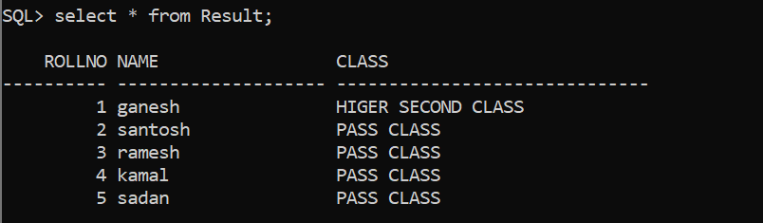

------------------

select * from stud_marks;



